Homework 8

Planning sketch:
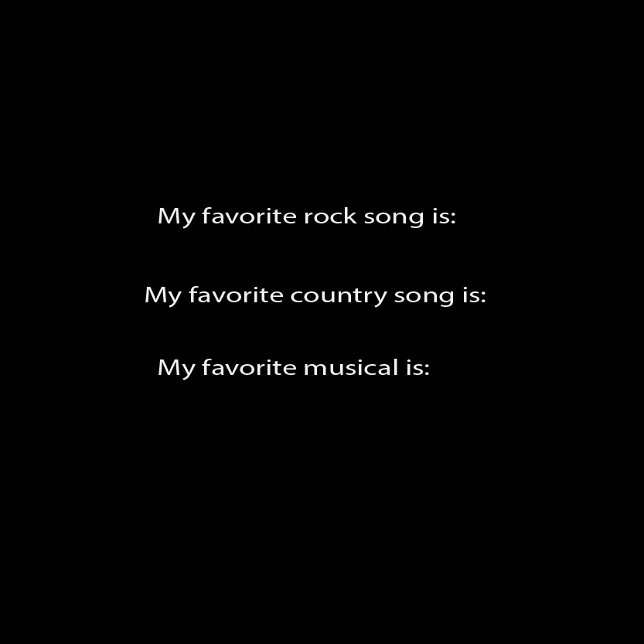

Screenshot:
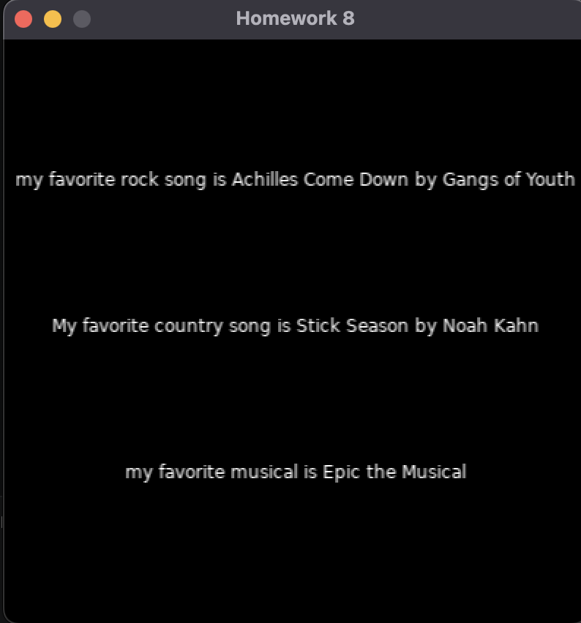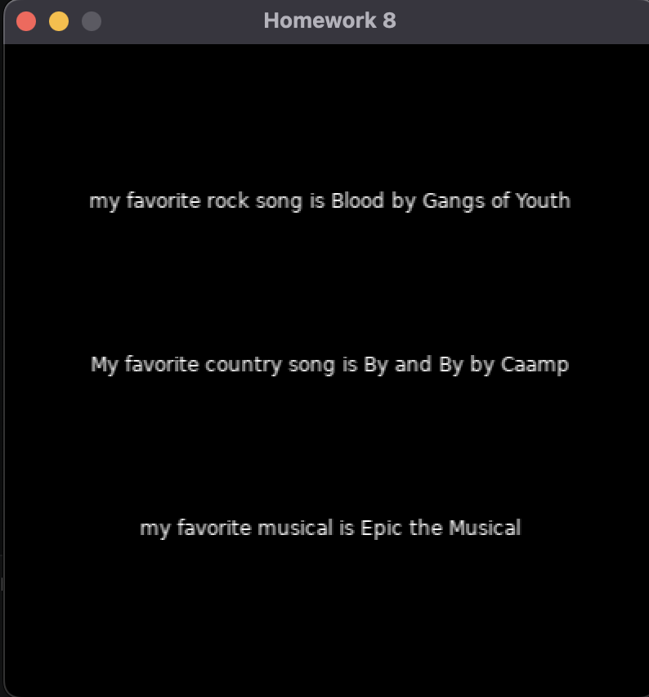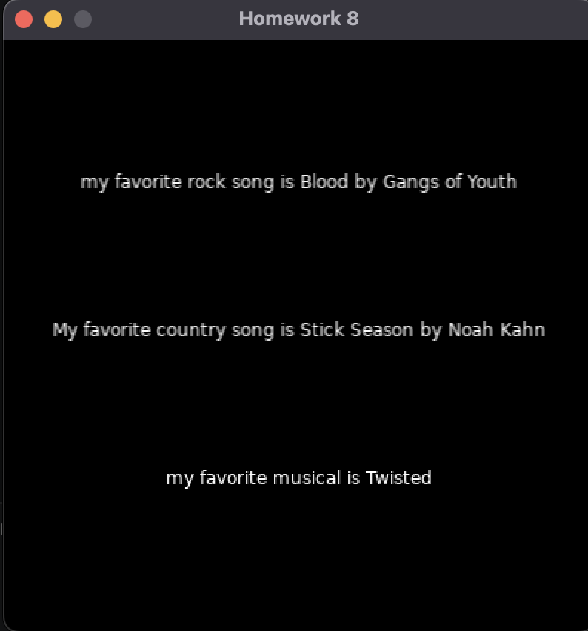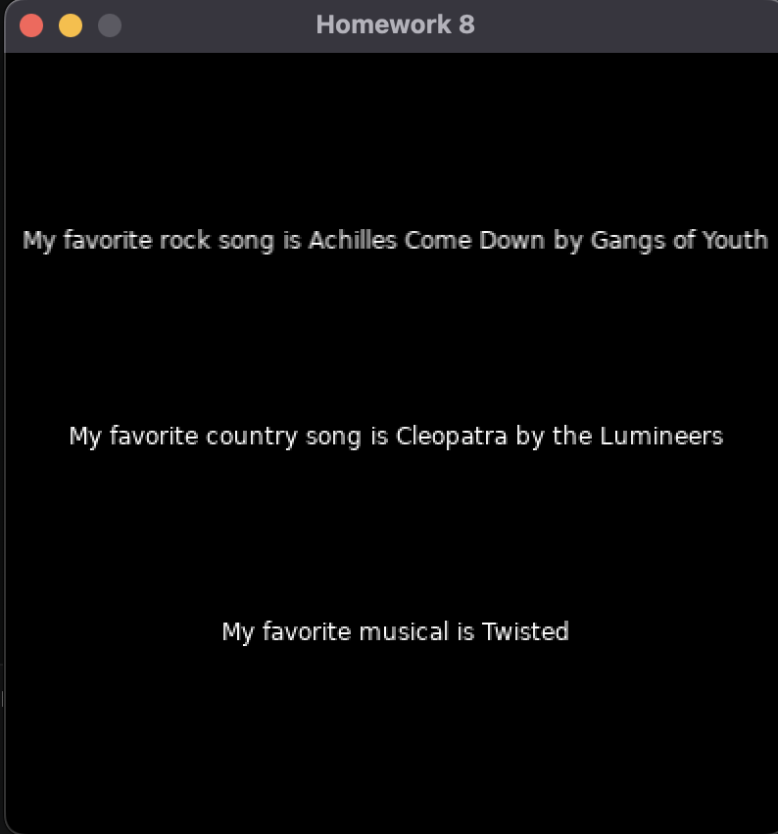

Main. Lua text:
require("L5")

--Create variable with an array of options
countrysongchoice= {"Cleopatra by the Lumineers", "Saturday Sun by Vance Joy", "Silver Lining by Mt. Joy", "All the Debts I Owe by Caamp", "Hymns to the Virgil by Hozier", "By and By by Caamp", "Stick Season by Noah Kahn"}
rocksongchoices= {"Achilles Come Down by Gangs of Youth", "Someone To You by Kings of Leon", "House of the Rising Sun by the Animals", "Blood by Gangs of Youth"}
musicals= {"Epic the Musical", "Hadestown" ,"Death Becomes Her", "Twisted", "Into the Woods", "Wicked"}
myText= "My favorite country song is "
myText2= "My favorite rock song is "
myText3= "My favorite musical is "
myfontSize=1

function setup()
size(400, 400)
angleMode(DEGREES)

windowTitle("Homework 8")

describe('Black background.')

background(0)
textAlign(CENTER)
textSize(12)
-- using random and the array name to get a random element from the array
sentenceBuilder(30)
end

function draw()

if mouseIsPressed == true then
background (0)
sentenceBuilder(myfontSize)
myfontSize= myfontSize + 1
end

end

function sentenceBuilder(myfontSize)
textSize(fontSize)
text(myText..random(countrysongchoice), width/2, height/2)
text(myText2..random(rocksongchoices), width/2, height/4)
text(myText3..random(musicals), width/2, height/1.3333333333)
end

Github Link:

https://github.com/bhavyamg1234/Creative-Code-Unit-2.git

